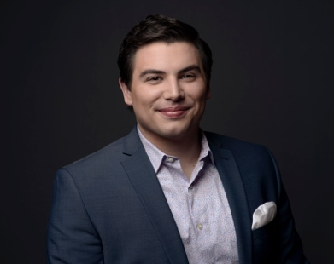
Eric Ferring
Tenor

American Tenor Eric Ferring, a native of Dubuque, Iowa, is an alum of Drake University and The Boston Conservatory under the tutelage of Dr. Rebecca Folsom. He is a graduate of the Pittsburgh Opera Resident Artist Program.

This season, Mr. Ferring returns to the Ensemble of the Ryan Opera Center at the Lyric Opera of Chicago. Performances during the season include Older Brother in Dead Man Walking and Tchaplitsky in Queen of Spades, while covering Count Almaviva in Il barbière di Siviglia and Don Ottavio in Don Giovanni. Future seasons include an anticipated debut with Santa Fe Opera as Tamino in Die Zauberflöte, as well as his company debuts in the same role with North Carolina Opera and New Orleans Opera. In concert, Mr. Ferring will join the Jacksonville Symphony Orchestra for Händel’s Messiah.

Performances during the past season at Lyric include his principal role appearance as Lurcanio in Ariodante with Maestro Harry Bicket, for which the Chicago Tribune declared him “the most noteworthy solo breakthrough of the production,” as well as the Young Servant in Elektra and both Gastone/Giuseppe in La traviata.

During his two seasons (2016-2018) as a Pittsburgh Opera Resident Artist, Mr. Ferring performed multiple roles including The Protagonist in the world premiere of Ashes & Snow (now known as Savage Winter) in collaboration with American Opera Projects, Flask in Moby-Dick, and Nemorino in L’elisir d’Amore. Mr. Ferring was an Apprentice Singer at Santa Fe Opera where he covered Oronte in Alcina and was awarded the Richard Tucker Memorial Scholarship.

He has also been seen at Opera Theatre of Saint Louis, Wolf Trap Opera, Seagle Music Colony, and Cedar Rapids Opera. In addition, Mr. Ferring was a recipient of a 2018 Sara Tucker Study Grant from the Richard Tucker Foundation, as well as a Career Grant from the Sullivan Foundation, Third Prize in the 2017 Gerda Lissner Foundation International Voice Competition, Top Prize in the American Opera Society of Chicago competition, and a Regional Encouragement Award at the 2017 Great Lakes Region of the Metropolitan Opera National Council Auditions. In 2015, Opera Theatre of Saint Louis presented Mr. Ferring a career award from the Richard Gaddes Fund for Young Artists given in recognition of his great vocal potential.

Mr. Ferring is managed by Fletcher Artist Management. For further materials and updates, please visit Mr. Ferring’s website at ericferring.com or his professional Facebook page.

